NSlookup — OS Command Injection
Proof of Concept Report — HackViser Lab
Prepared by: Aakash Singh | Date: May 31, 2026

Vulnerability Information

Author | Aakash Singh
Date | May 31, 2026
Lab | NSlookup — OS Command Injection
Platform | HackViser
Vulnerability Type | OS Command Injection via DNS Lookup Feature
Severity | Critical
CWE | CWE-78
Impact
The NSlookup/DNS query feature passes user input directly to OS-level commands. An attacker can inject additional OS commands to retrieve sensitive system information.
Reproduction Steps
Step 1: Identify the NSlookup/DNS query feature on the target application.
Step 2: Inject a hostname with appended OS command via a query separator (e.g., example.com; id).
Step 3: Capture the outgoing request in Burp Suite to confirm injection point.
Step 4: Observe that the command output is returned in the response.
Step 5: Retrieve the correct Squirrel hostname using the injected query.
Step 6: Review full output to confirm command execution and data exfiltration.
Evidence Screenshots
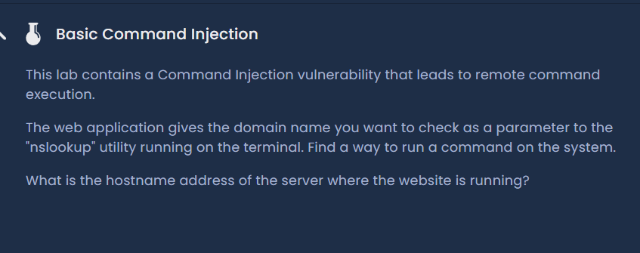
Figure 1: NSlookup feature — initial request
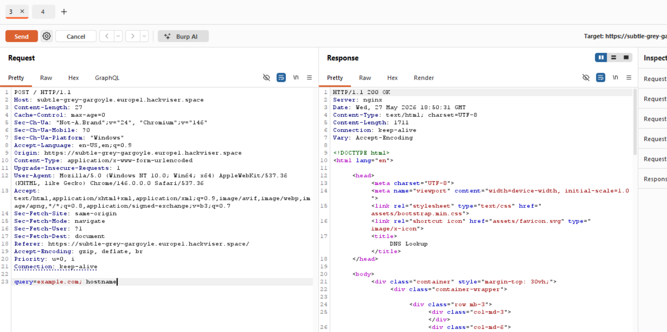
Figure 2: OS injection payload added in hostname query
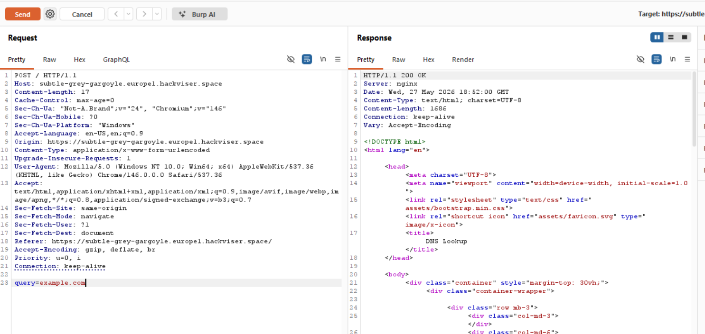
Figure 3: Burp request captured — injection confirmed
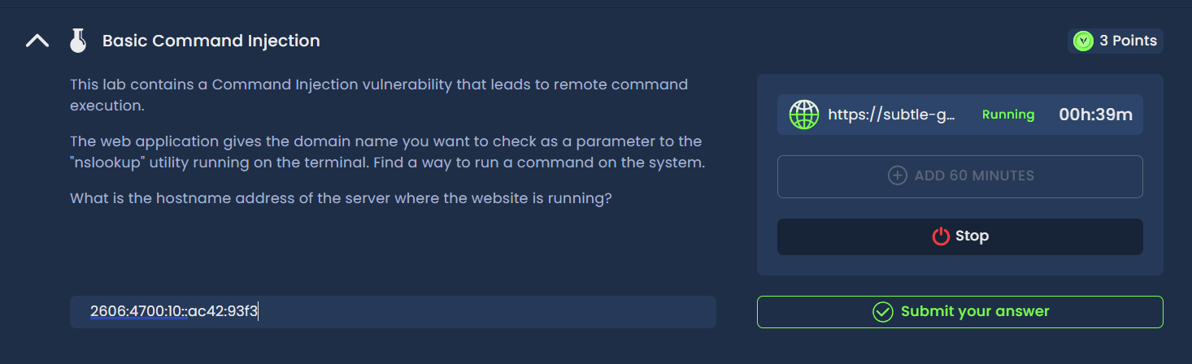
Figure 4: Response showing injected command output
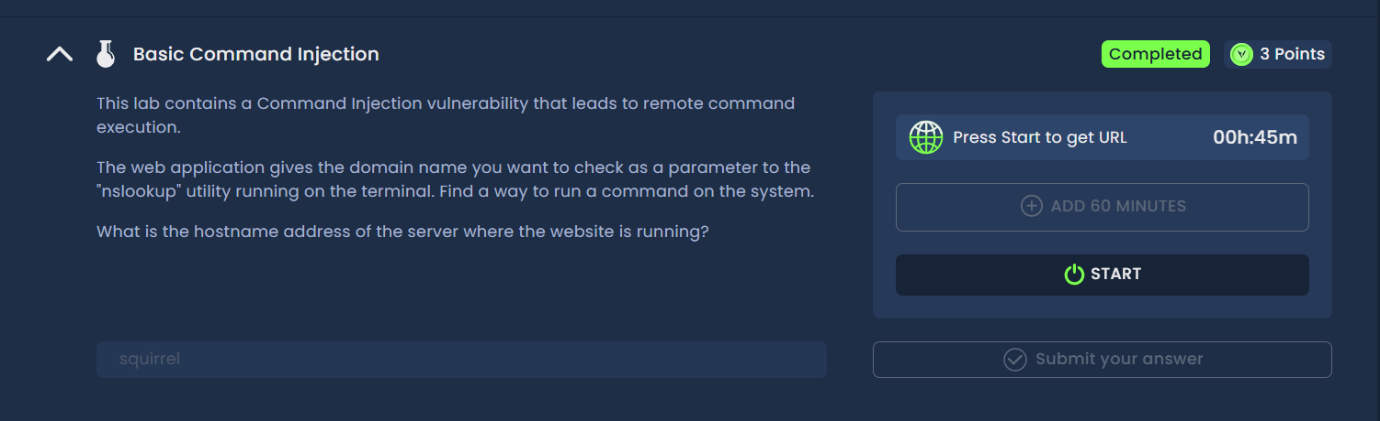
Figure 5: Correct Squirrel hostname retrieved
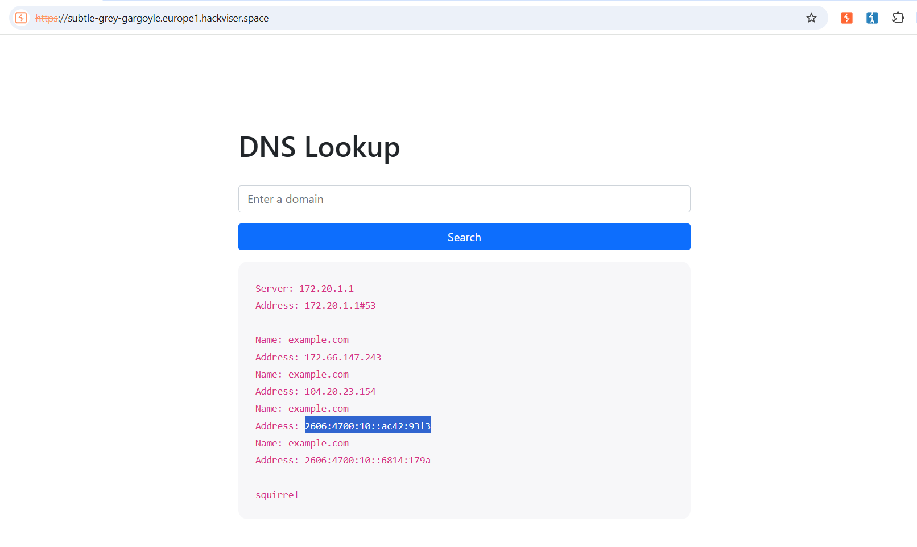
Figure 6: Full command output — lab solved
Remediation
Validate and sanitize all inputs to DNS/NSlookup features. Avoid constructing OS commands from user input. Use safe API wrappers instead of shell execution.
Confidential — Prepared by Aakash Singh | Security Research POC

